**Experiment-8**

**Aim:** To implement concept code for different indoor and outdoor Propagation models for the Cellular Mobile Communication.

**Activities:**

1. To Develop and implement Code of Propagation path loss using Okumar’s and HATA Model Path Loss Equations and plot the graph for Distance Vs Propagation path loss for comparative analysis.
2. Analysis of Different Path loss model for the Urban, Suburban and Rural Area.

**Theory:**

**Okumara's Model:**

* The model is ideal for using in cities with many urban structures but not many tall blocking structures. The model served as a base for the Hata Model.
* The Okumura model was built into three modes. The ones for urban, suburban and open areas. The model for urban areas was built first and used as the base for others.
* Coverage:

Frequency = 150–1500 MHz

Mobile station antenna height: between 1 m and 3 m

Base station antenna height: between 30 m and 1000 m

Link distance: between 1 km and 100 km

* L50(dB)=LFSL + AMU ( f ,d ) − G (hte) − G (hR) − GAREA where L50 = 50th percentile value of propagation path loss

AMU ( f ,d ) = Median Attenuation relative to free space

G (hte) = Base station antenna height gain factor

G (hR)= Mobile antenna height gain factor

GAREA = Gain due to type of environment

**Hata Model:**

The Hata model is for urban areas, which is also known as the Okumura–Hata model.This model incorporates the graphical information from Okumura model and develops it further to realize the effects of diffraction, reflection and scattering caused by city structures. This model also has two more varieties for transmission in suburban areas and open areas.

* Hata Model predicts the total path loss along a link of terrestrial microwave or other types of cellular communications.
* This particular version of the Hata model is applicable to radio propagation within urban areas. • This model is suited for both point to point and broadcast transmissions and it is based on extensive empirical measurements taken.
* PCS is another extension of the Hata model. The Walfisch and Bertoni model is further advanced.
* Mathematical Formulas:
* For urban areas:

L50(dB)=69.55 + 26.26 log ( fc) − 13.82 log (hte) − a(hR)+ (44.9 − 6.5 log (hte) ) log (d )

**Walfisch Model:**

* This semi-empirical model is a combination of the models from J. Walfisch and F. Ikegami.

It was further developed by the COST 231 project.

* It is now called the Empirical COST-Walfisch-Ikegami Model.
* The model considers the buildings in the vertical plane between the transmitter and the receiver. Street widths, buildings heights as well as transmitter and receiver heights are considered.
* As only these characteristic values are considered for the computation, the

The Walfisch-Ikegami model is a statistical model. But the model distinguishes between two situations, the "line of sight" (LOS) and the "none line of sight" (NLOS) situation.

LOS Situation:

For the LOS-case the prediction is very easy, as only one equation with two parameters are necessary.

Lp = 42.6 + 26 1og ( d /km )+20 1og ( f /MHz ) NLOS Situation:

The NLOS equations are more complicated. The loss in the NLOS case is the sum

of the free space loss l0, the multiple screen diffraction loss lmsd and the rooftoptostreet diffraction loss lrts.

The free space loss:

Lp=32.44+20.1g ( f /MHz )+20.1g( d/ km )

Algorithm:

Step1: Initialize hte (100)%Base Station height hre (10) %Mobile Station height fc (900*10^6) d (1:0.01:20) c (3*10^8)

Step2: Calculate L(dB) of different pathloss models.

(A)Okumura’s Model

L50 = Lf + 43 - Ghte - Ghre - 9

(B)Hata Model (i)Urban urban = 69.55 + 26.16*log10(fc) + (44.9 - 6.55*log10(hte))*log10(d) - 13.82*log10(hte) - ahre

(ii)Suburban suburban = 69.55 + 26.16*log10(fc) + (44.9 - 6.55*log10(hte))*log10(d)- 13.82*log10(hte)-ahre - 2*(log10(fc/28)).^2 - 5.4

(iii)Rural rural = 69.55 + 26.16*log10(fc) + (44.9- 6.55*log10(hte))*log10(d) - 13.82*log10(hte) - ahre - 4.78*(log10(fc)).^2 + 18.33*(log10(fc))- 40.94

(C)Extended Hata Model

(i)Suburban

Cm = 0

L50 = 46.3 + 33.94*log10(fc) - 13.82*log10(hte) - ahre + (44.9 - 6.55*log10(hte))*log10(d)+Cm (ii)Urban

Cm = 3

L50 = 46.3 + 33.94*log10(fc) - 13.82*log10(hte)- ahre + (44.9 - 6.55*log10(hte))*log10(d)+ Cm

Step3: Plot all Path Loss Propagation Model with L(dB) and D(km).

Python Code: import numpy as np import math import matplotlib.pyplot as plt

# Step 1: Initialize parameters fc = 900e6 # Frequency in Hz hte = 100 # Base Station height in meters hre = 10 # Mobile Station height in meters c = 3e8 # Speed of light in meters per second d = np.arange(1, 20.01, 0.01) # Range of distances from 1 to 20 km

# Initialize empty arrays to store path loss values

L_Okumura = np.zeros(len(d))

L_Hata_Urban = np.zeros(len(d))

L_Hata_Suburban = np.zeros(len(d))

L_Hata_Rural = np.zeros(len(d))

L_Extended_Hata_Suburban = np.zeros(len(d))

L_Extended_Hata_Urban = np.zeros(len(d))

# Step 2: Calculate L(dB) of different path loss models

# Loop through the distance values and calculate path loss for i, dist in enumerate(d):

# Okumura's Model

Ghte = 20 * np.log10(hte / 200)

Ghre = 20 * np.log10(hre / 3)

Lf = 20 * np.log10(fc / 28)

L_Okumura[i] = Lf + 43 - Ghte - Ghre - 9

# Hata Model

L_Hata_Urban[i] = 69.55 + 26.16 * np.log10(fc) + (44.9 - 6.55 * np.log10(hte)) * np.log10(dist) - 13.82 * np.log10(hte)

ahre = (1.1 * np.log10(fc) - 0.7) * hre - (1.56 * np.log10(fc) - 0.8) L_Hata_Urban[i] -= ahre

L_Hata_Suburban[i] = L_Hata_Urban[i] - 2 * (np.log10(fc / 28))**2 - 5.4

L_Hata_Rural[i] = L_Hata_Urban[i] - 4.78 * (np.log10(fc))**2 + 18.33 * np.log10(fc) - 40.94

# Extended Hata Model

Cm_Suburban = 0

L_Extended_Hata_Suburban[i] = 46.3 + 33.94 * np.log10(fc) - 13.82 * np.log10(hte) - ahre +

(44.9 - 6.55 * np.log10(hte)) * np.log10(dist) + Cm_Suburban

Cm_Urban = 3

L_Extended_Hata_Urban[i] = 46.3 + 33.94 * np.log10(fc) - 13.82 * np.log10(hte) - ahre +

(44.9 - 6.55 * np.log10(hte)) * np.log10(dist) + Cm_Urban

# Step 3: Plot all Pathloss Propagation Models

plt.figure(figsize=(10, 6)) plt.plot(d, L_Okumura, label="Okumura's Model") plt.plot(d, L_Hata_Urban, label="Hata Model (Urban)") plt.plot(d, L_Hata_Suburban, label="Hata Model (Suburban)") plt.plot(d, L_Hata_Rural, label="Hata Model (Rural)") plt.plot(d, L_Extended_Hata_Suburban, label="Extended Hata Model (Suburban)") plt.plot(d, L_Extended_Hata_Urban, label="Extended Hata Model (Urban)")

plt.xlabel('Distance (km)') plt.ylabel('Propagation Path Loss (dB)') plt.title('Path Loss Propagation Models') plt.grid(True) plt.legend() plt.show()

**Output:**

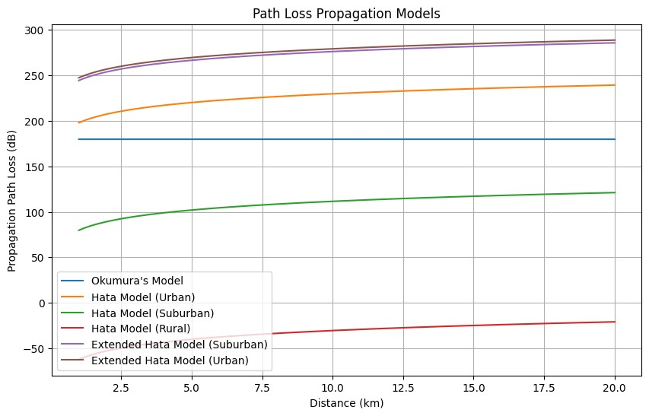

**B. Analysis of Different Path loss models for the Urban, Suburban and Rural Area. Okumura Model:**

* Predicts moderate path loss in urban areas with many structures and relatively few tall blocking structures.
* Ideal for frequencies between 150 MHz and 1500 MHz, base station heights between 30 m and 1000 m, and mobile station heights between 1 m and 3 m. ● Path loss increases with distance and frequency.

Hata Model:

* A simplified version of Okumura's model.
* Predicts higher path loss in urban, suburban, and rural areas.
* Takes into account factors like frequency, antenna heights, and distance.
* Path loss increases with distance and is influenced by the height of base stations and mobile stations.

Extended Hata Model:

* An extension of the Hata model with correction factors (Cm).
* Predicts path loss in urban and suburban areas.
* Path loss is adjusted based on frequency, antenna heights, and environmental conditions.
* Provides more accurate predictions in different scenarios.

**Conclusion:**

In this we learnt about different path loss in urban, suburban, and rural with the help of the graph given above with the help of path loss models like Okumara and Hata.